Elements Test

Name _______________________________ Mark /55

|  |  |  |
| --- | --- | --- |
| Name | Symbol | Metal or non-metal |
|  | O |  |
|  | Na |  |
|  | N |  |
| Carbon |  |  |
| Silver |  |  |
| Gold |  |  |
|  | Cl |  |
|  | Mg |  |
|  | Mn |  |
| Calcium |  |  |
| Lead |  |  |
| Sulfur |  |  |
|  | Ne |  |
|  | He |  |
|  | H |  |
| Iodine |  |  |
| Iron |  |  |
| Barium |  |  |
|  | F |  |
|  | Zn |  |
|  | Al |  |
| Phosphorus |  |  |
| Cobalt |  |  |
| Copper |  |  |
|  | W |  |

(50marks)

|  |  |
| --- | --- |
| Word | Meaning |
|  | Can be hammered into sheets |
|  | Can be drawn out into wires |
|  | Will shatter if hit with a hammer |
|  | Shine produced by polishing |
|  | A characteristic that can be used to describe something |

(5 marks)

[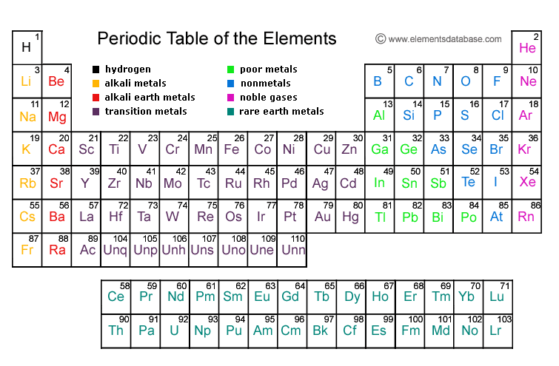](http://www.google.com.au/url?sa=i&rct=j&q=periodic+table&source=images&cd=&cad=rja&docid=V9DydE2FHov3qM&tbnid=6B3X9pbi3Dl0MM:&ved=0CAUQjRw&url=http%3A%2F%2Fwww.elementsdatabase.com%2F&ei=NNKSUdjBEsrylAWYlICABg&psig=AFQjCNGe0yeMdJ-n17w2aHaKkPbk3RT5lA&ust=1368662959518278)